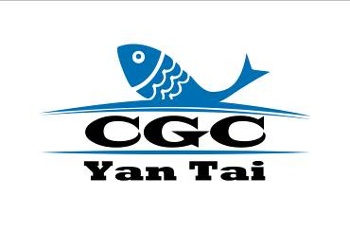
CGC (Yantai) Show 2017
Booth Booking Form
Date: May 13-15, 2017，Venue: Yantai International Exposition Center

Please send back the form to the organizer by e-mail, lijiang@chinafish.cn or by fax, +86-10-58203100

Company Name
Address
Zip Code |  | Contact Person
Tel |  | Mobile Phone
Fax |  | E-mail
Website
Category of Company | □ Manufacturer □ Wholesaler □ Retailer □ Agent  □ Impt./Expt. Company □ Organization or Association  □ Media □ Others:
Main Products
Preferred Booth Size | □ 9㎡ □ 18㎡ □ 27㎡ □ 36㎡ □ others
Booth Special Request | We would like to be located near  We would rather not be located near
Signature |  |  | Date
Remarks

Organizer: Beijing Admire Exhibition Co., Ltd.
Phone: +86-10-58203101/02/03 Fax: +86-10-58203100
E-mail: lijiang@chinafish.cn Website: www.cgcexpo.com/yantai/

