 | CGC EXPO (SPRING) 2026  HOTEL BOOKING FORM  Apr. 25-27, 2026  Weihai International Economic and Trade Exchange Center
*Please return this form to CGC EXPO. We will issue a Hotel Confirmation Letter within 3 working days.
HOTEL RESERVATION:
Location | Hotels | Room Type | Price (RMB) |  | 1st Choice | 2nd  Choice | Number of Rooms
Connected to the Venue | Weihai North Star International Business Hotel  （Breakfast for two included）  0km to the venue | Superior | RMB 370 NET  (☐2 Beds ☐1 Bed) |  | ☐ | ☐
Connected to the Venue |  | Business | RMB 390 NET  (☐2 Beds ☐1 Bed) |  | ☐ | ☐
Connected to the Venue |  | Executive | RMB 698 NET  (☐1 Bed) |  | ☐ | ☐
Connected to the Venue |  | Suite | RMB 1,808 NET |  | ☐ | ☐
Connected to the Venue | 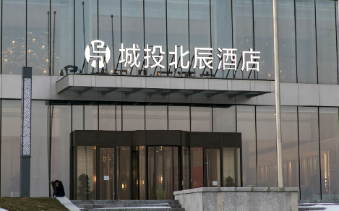 |  |  | 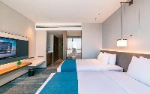
Connected to the Venue | Crowne Plaza Weihai Binhai Hotel  (Breakfast options: single or double)  0km to the venue | Superior | RMB 500 NET  (☐1 Bed / 1 Breakfast)  RMB 550 NET  (☐1 Bed / 2 Breakfasts) |  | ☐ | ☐
Connected to the Venue |  | Superior | RMB 500 NET  (☐2 Beds / 1 Breakfast)  RMB 550 NET  (☐2 Beds / 2 Breakfasts) |  | ☐ | ☐
Connected to the Venue |  | Superior  (Sea View) | RMB 600 NET  (☐1 Bed / 1 Breakfast)  RMB 650 NET  (☐1 Bed / 2 Breakfasts) |  | ☐ | ☐
Connected to the Venue |  | Superior  (Sea View) | RMB 600 NET  (☐2 Beds / 1 Breakfast)  RMB 650 NET  (☐2 Beds / 2 Breakfasts) |  | ☐ | ☐
Connected to the Venue | 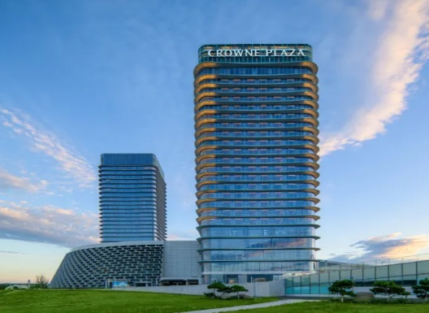 |  |  | 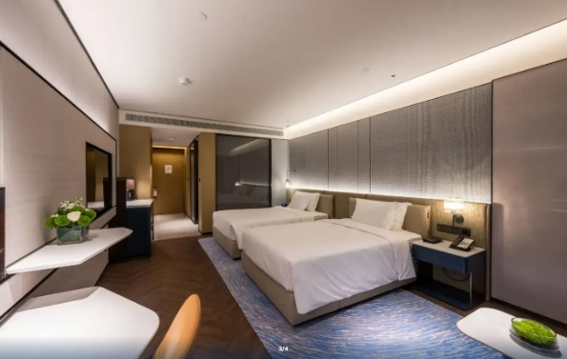
Nearby: Weihai Railway Station/  Jiulongcheng Downtown  (Show Shuttle Buses Provided) | Weihai Kowloons Hotel  （Breakfast for two included）  16km from the venue, 20-minute drive | Standard | RMB 298 NET (2 Beds) |  | ☐ | ☐
 |  | Standard | RMB 318 NET (1 Bed) |  | ☐ | ☐
 | 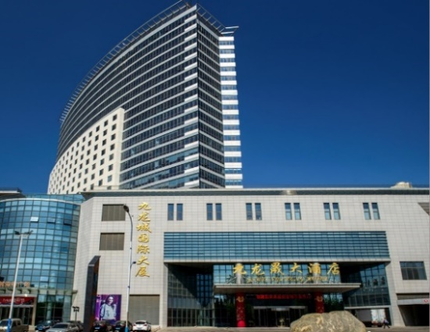 |  |  | 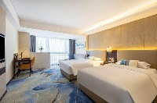
(Reference: Exchange rate USD1.00 ≈ RMB 7.20)
Note:
- Reference Exchange Rate: the fee is to be paid according to the exchange rate released by Bank of China on the payment day.
- Special room rates are available for bookings made before April 20, 2026. The room rates will be higher after this date. Booking is on the first-come-first-served basis.
- Breakfast & Service charge included.

GUEST INFORMATION
Name: (Mr. /Mrs. /Ms.): Badge No:
Name: (Mr. /Mrs. /Ms.): Badge No:

Check-in Date: Your check-in date Check-out Date: Your check-out date
Later Check-in (after 16:00): ☐ Yes Check-in Time:
(Or please advise your check-in time once confirmed

Shuttle Information:
□ Shuttle bus between hotel and venue
A one-way shuttle bus ticket between the hotels and the venue is RMB 8.00 per person.

Signature: Date: Signing date

Contact
Mr. Li Jiang  President of China Fish  Tel: +86-10-5820 3101 / 02 / 03  Lijiang@chinafish.cn  www.chinafishshow.org  China Fish Official Account (WeChat)  Don’t miss a thing about China Fish!   | Ms. Cheers Hsu  For Overseas Buyers:  service@chinafish.cn  WeChat: CHINAFISH1991  Mobile Phone: +86-13810708871  Regions: Europe, Japan, Korea   | Ms. Emily Zhang  For Overseas Buyers and exhibitors:  service_d@chinafish.cn  WeChat: CHINAFISH88  Mobile Phone: +86-15210566392  Regions: Africa, Oceania, America, Asia (Except Japan and Korea)  