 | CGC EXPO (AUTUMN) 2025  HOTEL RESERVATION FORM  Weihai International Economic and Trade Exchange Center, Weihai, China September 26-28, 2025
Please send the form back by Email to lijiang@chinafish.cn. We will send you a Hotel Confirmation Letter within 3 working days.
HOTEL RESERVATION:
Location | Hotels | Room Type | Price (RMB) |  | 1st Choice | 2nd  Choice | Number of Rooms
Connected to the Venue | Weihai North Star International Business Hotel  (0km to the venue) | Superior | RMB 380 NET  (☐2 Beds ☐1 Bed) |  | ☐ | ☐
Connected to the Venue |  | Business | RMB 400 NET (2 Beds) |  | ☐ | ☐
Connected to the Venue |  | Business | RMB 440 NET (1 Bed) |  | ☐ | ☐
Connected to the Venue |  | Executive | RMB 698 NET (1 Bed) |  | ☐ | ☐
Connected to the Venue |  | Suite | RMB 1,808 NET |  | ☐ | ☐
Connected to the Venue | 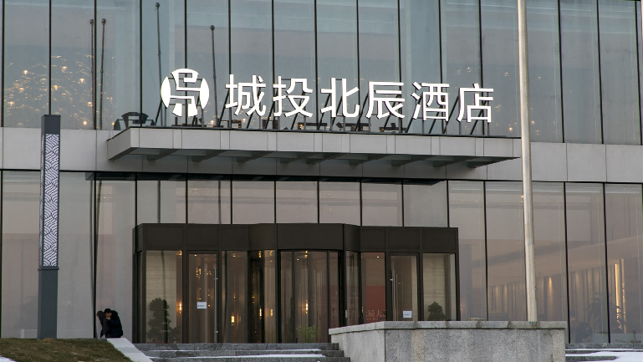 |  |  | 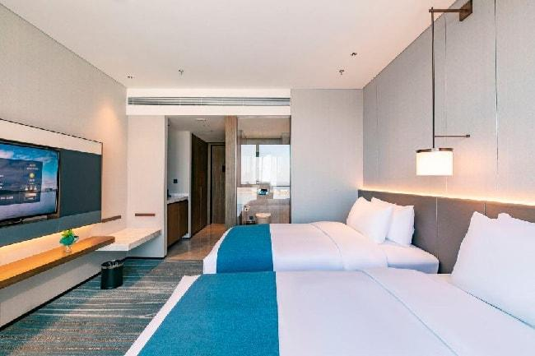
Nearby: Weihai Railway Station/  Jiulongcheng Downtown  (Show Shuttle Buses Provided) | Weihai Bliss Int' l Hotel  (17km from the venue, 22-minute drive) | Business | RMB 380 NET  (☐2 Beds ☐1 Bed) |  | ☐ | ☐
 | 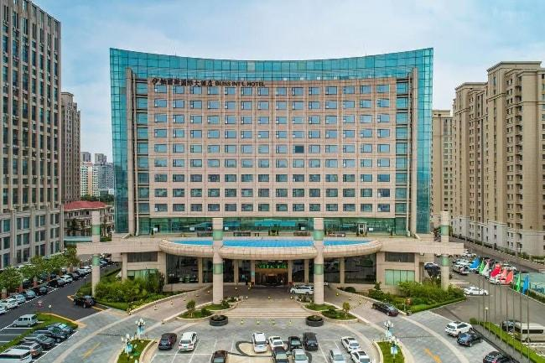 |  |  | 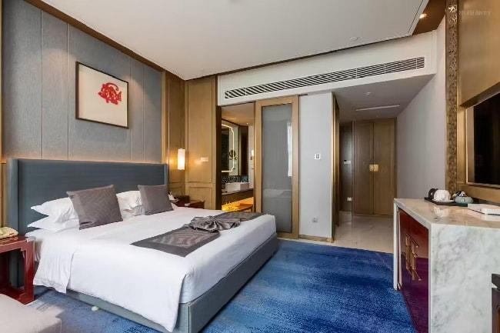
 | Weihai Kowloons Hotel  (16km from the venue, 20-minute drive) | Standard | RMB 368 NET (2 Beds) |  | ☐ | ☐
 |  | Standard | RMB 408 NET (1 Bed) |  | ☐ | ☐
 | 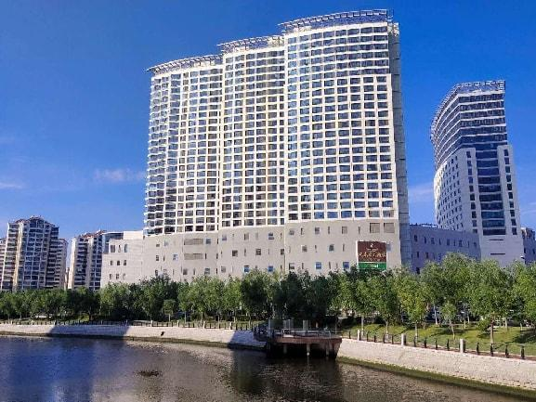 |  |  | 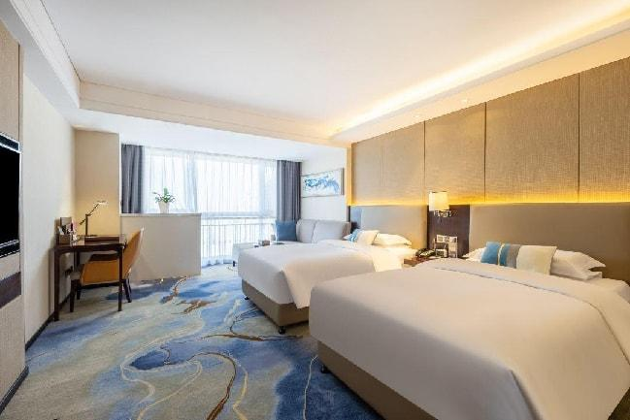
 | *Note: Additional comfort-class hotels priced around 300 RMB will be introduced in early August
(Reference: Exchange rate USD1.00 ≈ RMB 7.20)
Note:
- Exchange Rate: Payment will be calculated based on the Bank of China’s exchange rate on the day of transaction.
- Special Room Rates: Discounted rates are available for stays between September 24–28, 2025. For early check-in or late check-out requests, please contact us in advance.
- Pricing: All room rates are net (inclusive of taxes and service fees).
- Invoicing: Invoices will be issued by the hotel upon request at the front desk during checkout.
- Smoking Policy: In accordance with regulations, smoking is strictly prohibited in all areas of the hotel.

GUEST INFORMATION
Name: (Mr. /Mrs. /Ms.): Badge No:
Name: (Mr. /Mrs. /Ms.): Badge No:
Name: (Mr. /Mrs. /Ms.): Badge No:

Check-in Date: September , 2025 Check-out Date: September , 2025
Later Check-in (after 16:00): ☐ Yes Check-in Time:
(Or please let us know your check-in time as soon as you know it)

Shuttle Service Information:
□ Shuttle bus between the hotel and venue
- A single one-way ticket is priced at RMB 8.00/person.

Signature: Date:

Contact
Emily Zhang/ Cheers Hsu
Email: service_d@chinafish.cn/service@chinafish.cn
Tel: +86-10-58203101/2/3 Ext. 608
Phone: 0086-15210566392/0086-13520741597/0086-13810708871
WeChat: CHINAFISHSHOW/CHINAFISH1991/ CHINAFISH88
Website: www.chinafishshow.org

