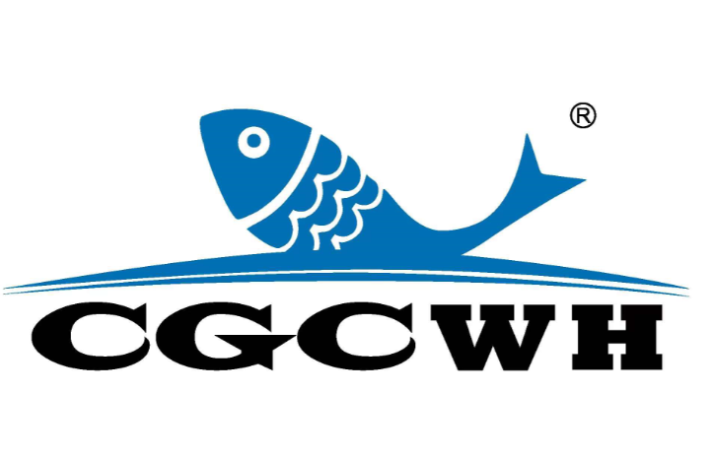 | CGC EXPO 2024  INTERPRETER SERVICE FORM  Weihai International Economic and Trade Exchange Center, Weihai, China Oct. 12-14, 2024
If you need interpreter service provided by CGC EXPO organizer, please send the form back to us by Fax: +86-10-58203100, or E-mail: lijiang@chinafish.cn

Name: ____________________________________ Badge No.:____________________
Company: _______________________________________________________________
Language: (1) or (2)
Total service days: days, from October to October 2024.
Special requests for the interpreters:

Note:
Interpreter’s working hour:
9:00am - 5:00pm.

Price:
English: RMB 300/person/day or US$ 50/person/day (Including bank service fee.)
For other language, please consult with your coordinator.

Notes:
1. No found return if you cancel your interpreter service without written notice to Organizer before Sep. 20, 2024.

Deadline of reservation:
Sep. 20, 2024

Confirmation:
The order can not be confirmed without advanced payment for the charged languages.

