

CGC (WEIHAI) EXPO 2017

The 10th China (Weihai) Fishing Gear Manufacturing Center Expo

Oct. 13-15, 2017，Weihai International Exhibition Center, China

EXHIBITOR SERVICE MANUAL

www.cgcexpo.com
Tel: +86-10-58203101/2/3 Fax: +86-10-58203100 (Beijing Office)
Tel: +86-631-5625630 Fax: +86-631-5624630 (Weihai Office)
WELCOME MESSAGE



Dear CGC (WEIHAI) EXPO 2017 Exhibitors,

First warmly welcome you to exhibit at CGC (WEIHAI) EXPO 2017, to be held on Oct. 13-15, 2017, we hereby would like to take this opportunity to extend our gratitude for your great support.

The Exhibitor Manual provides you with all important information, please read it carefully and use it as your exhibiting guidance. Besides, all blank forms in the manual are needed to be filled and send back to the organizer by the deadline, so that we could arrange the required service for you in time. We sincerely hope that we could have a pleasant cooperation together.

We are looking forward to seeing you at CGC (WEIHAI) EXPO 2017 in China.

Sincerely yours,

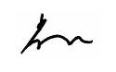
Li Jiang
President, CGC (Weihai) Expo

CONTENTS
General Information
Information and tips
1.1 About CGC (WEIHAI) EXPO 2017
1.2 Venue Introduction
1.3 Booth Floor plan
1.4 Official Service Suppliers
1.5 Exhibition Contact
1.6 Exhibitor Notice
1.7 Intellectual Property Rights Regulations

Management and service
1. Public Facilities and Services
  - Regulations for use of Exhibition Hall
  - Water and electricity management regulations
  - Fire Safety Stipulation

2. Certificates Management
  - Exhibitors badges
  - Construction certificate

3. Standard Booth Construction
3.1 Standard Booth
3.2 During negotiation between booth structures

4. Raw Space Booth
4.1 Booth Construction official Service Suppliers
4.2 Booth Construction & Management Regulations
4.3 Raw Space Booth construction process
4.4 Booth Construction Over-time Work
4.5 Water/Electricity/Compressed air Supply

5. Service Order
5.1 On-site service booking (Exhibition furniture、lighting、office、network etc.）
5.2 Hotel Reservation
5.3 Translation service
5.4 Visa invitation
5.5 Exhibits transport
5.5.1 Exhibitor own commissioned transport
5.5.2 Exhibition designated transport company
5.5.2.1 Exhibits transport guide
5.5.2.2《Power of attorney》

6. Exhibition promotion
6.1 Exhibitor Information
6.2 Exhibition Advertising
6.3 Catalogue Advertising
6.4 Exhibition Hall Advertising
6.5 Exhibition Sponsorship

Forms & Deadline:
Item | Order Forms | Deadline
01 | Exhibitors Badges Form (Necessary) | Aug. 20
02 | Exhibitors Registration Form (Necessary) | Aug. 20
03 | Hotel Reservation Form | Sep. 20
04 | Visa Invitation Form | Sep. 20
05 | Translation Service Form | Sep. 20
06 | Catalogue Advertisement | Sep. 06
07 | Exhibition Furniture, Lighting, Office, Network Application From | Sep. 20
08 | During Negotiation between Booth Structures | Sep. 20

GENERAL INFORMATION

  - About CGC (WEIHAI) EXPO 2017

Name: The 10th China (Weihai) Fishing Gear Manufacturing Center Expo (CGC (WEIHAI) EXPO 2017)
Date: October 13-15, 2017
Venue：Weihai International Exhibition Center, (No. 58 Haibin Mid Road, Weihai)
Organizer: China International Trade Promotion Committee (Weihai Committee)
Weihai Aohua Exhibition Co., Ltd.

Co-organizer: Weihai Aohua Exhibition Co., Ltd.

Show Schedule：
Installation (space) | October 11 / Wednesday | 8:30-17:00
Installation (All booths) | October 12 / Thursday | 8:30-21: 00
Show Time | October 13/ Friday | 8:30-17: 00
Show Time | October 14 / Saturday | 8:30-17: 00
Show Time | October 15 / Sunday | 8:30-16: 00
Dismantling (All booths) | October 15 / Sunday | 16:00-21:00

  - Venue Introduction
Weihai International Exhibition Center is located on the coast between the central city district and the economic and technical development zone.

Weihai International Exhibition Center (WIEC)
No. 58 Haibin Mid Road, Weihai

www.intexwh.com, Tel: +86-631-5181806

CGC (WEIHAI) EXPO 2017 use the first floor of the main exhibition hall and sencond floor of Hall A, exhibition area of 26,000 square meters, the outdoor exhibition area of 7,000 square meters and the retail area of 1,000 square meters. That is total 34,000 square meters. The visitors can reach through the stairs or the escalators in the central square, while the exhibits can be carried there through the freight forwarding entrance.
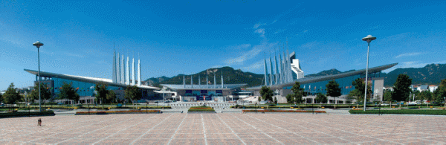

Venue traffic：
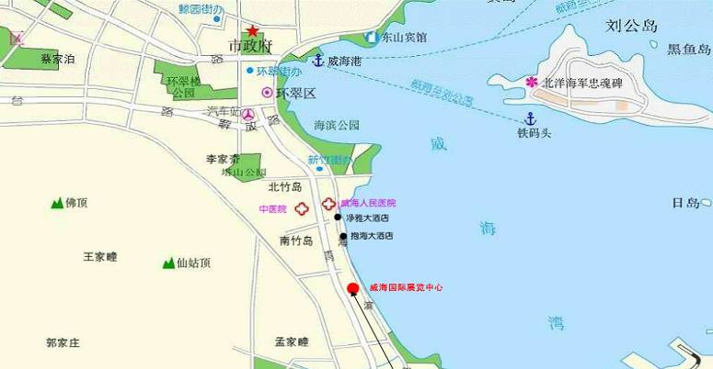

From Weihai International Exhibition Center
To Weihai Airport: 35 km (about 25 minutes by car)
To Yantai Airport: 40 km (about 40 minutes by car)
To Weihai Train Station: 6 km (about 10 minutes by car)
To Weihai Seaport: 10 km (about 15 minutes by car)

  - Layout & Booth Floor plan

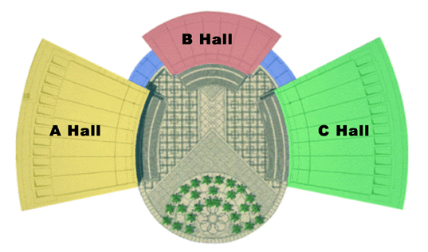

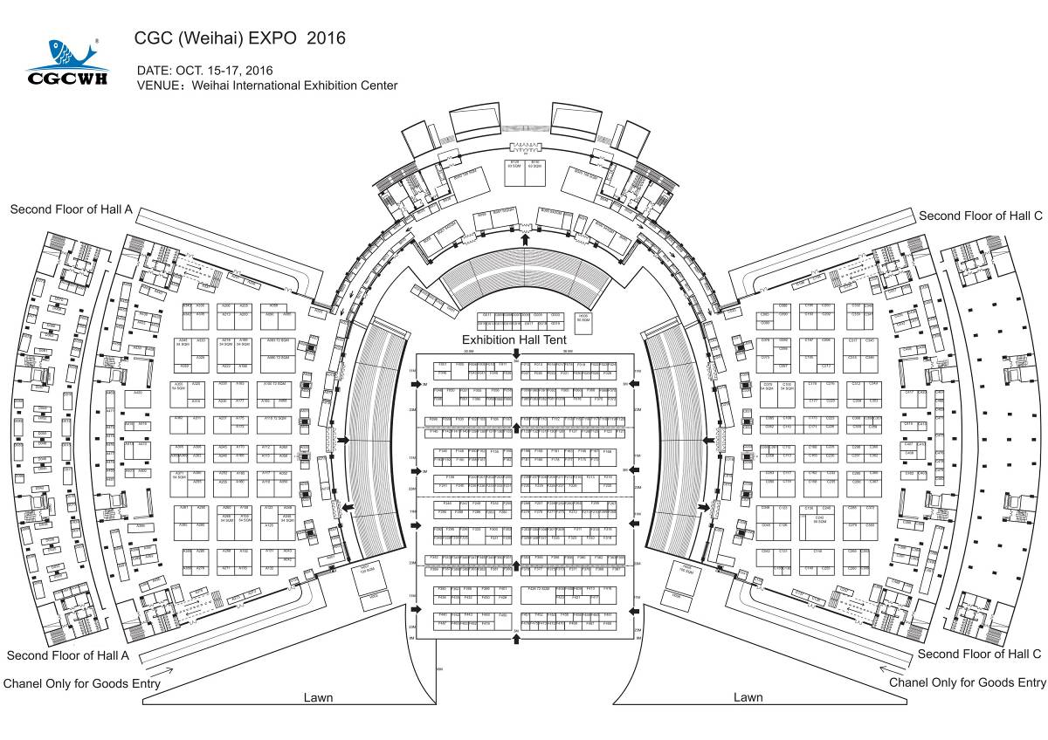

  - Official Service Suppliers

For exhibitor’s convenience, Exhibitors are advised to use organizer designated official service suppliers to provide transportation, raw space construction, business services etc.
Official Freight Forwarder：

Kerry EAS International Logistic Co., Ltd, WeiHai branch
Contact person：Wang Zhaolin（+86-13863138933），
Email： Zhaolinwang@kerryeas.com
Tel：+86-631-3668023 / 3668025
Fax：+86-631-3668026

Room 103, First floor, No. 30 Haibin South Rd.,
WeiHai, Shandong Province 264200, China

DEPPON LOGISTICS Co., LTD, WeiHai branch
Contact person：Manager Wang（+86-13963149954），
Email： 912655984@qq.com
Tel：+86-631-3672108 / 3672088
Fax：+86-631-3672118
Web: www.deppon.com

No. 198-6, Huoju Rd., High-Tec District, WeiHai, Shandong
Province 264209, China

Official Constructor：
It is responsible for the exhibition standard booth construction, special decoration management, exhibition leasing-related services etc. Before September 20, 2017, raw space booth service suppliers should contact Official Exhibition Constructor and apply for construction procedures.

Weihai International Convention & Exhibition Co., Ltd.
(Official Exhibition Constructor)
Contact person：Qi Liang (Call Phone: +86-18663153716)
Tel：+86-631-5181801
Fax：+86-631-5182509
E-mail: 1660216354@qq.com
www. Intexwh.com

Weihai International Exhibition Center, (No. 58 Haibin Mid Road, Weihai，Shandong Province 264200, China

Guangfunaji Exhibition & Show Co., Ltd.
Contact Person: Chen Guozheng (Cell phone: +86-13910234923)
Tel: +86-10-57427990
Fax: +86- 10-57571869 ext 8006
E-mail: 361155804@qq.com
www.guangfunaji.com

Rm. 0227, South Building 4, Zhonghong Xiangsu, Wuliqiao,, Chaoyang District, Beijing, 100102, China

Beijing Horizon Exhibition & Show Co., Ltd.
Contact Person: Chen Dongran (Cell phone: +86-13910181313)
Tel: +86-10-67662180/87602180
E-mail: horizon8888@vip.sina.com
www.horizon-s.com.cn

No. 3#-4-404, Zone B, 1st Hongbo Jiayuan, Chaoyang District,
Beijing, 100176, China

1.5 Exhibition Important Contact：

Mrs. Emily Zhang (for International Exhibitors)
Tel: +86-10-5820 3101/02/03
Fax: +86-10-5820 3100
E-mail: service_d@chinafish.cn

Mr. Li Jiang (President)
Tel: +86-10-58204979
E-mail: Lijiang@chinafish.cn

Weihai Office:
RM 603,Block B, Haiyuejianguo Hotel, No177, Wenhua RD.,
Weihai, Shandong Province 264200, China

Beijing Office:
9/F, Building #5, Wanda Plaza, No. 93 Jianguo Rd.
Beijing 100022, China

1.6 Important Notice

1) Admission requirements: Exhibitors should comply with show time and make stay for their own booth at night 9:00 (October 12) during the last day of exhibition installation, for avoiding the exhibits lost. During the exhibition time, please enter the hall about half an hour earlier than the audience. Minor is declined for admission.

2) Using of the site: Exhibitors consciously protect the environment of exhibition hall, the exhibition hall floors, walls and related facilities. If related facilities are damaged, the relevant the exhibitors should compensate according to relevant regulations of the exhibition hall.

3) Site clean: Exhibitors, constructors are responsible for the internal cleaning of booth during the installation period. Official constructor carry out the cleaning of public areas during show time, exhibitors are responsible for their own booth cleaning, For Cleaning service is needed to apply for Official constructor and pay the associated costs.

4) Intellectual property: Exhibitors ensure that the exhibits do not involve the infringement of intellectual property rights. Such as the infringement dispute in site, organizer has the right to request arising exhibits from the shelf; exhibitor is responsible for all the consequences resulting by these.

5) Exhibit out of the Hall: Exhibitors get the issued out bar at the registration desk, and to handle the procedures of exhibit out of the hall.

6) The public areas of exhibition hall are prohibited to put the sundries.

7) Apply for Overtime: For exhibitor or structures to work overtime, they need to apply for the Commercial Service of official constructor before 15:00 in the same day

8) Service prices: All applications should be within the prescribed period of before opening, delay is subject to a 30% rush fee.

9) Promotion: Exhibitors distribute promotional materials only within their own booth.

10) Insurance of Exhibits: Exhibitors should be required insurance for its exhibits and the property insured, purchase employer's liability insurance for their employees, public liability insurance for the invited audience, if the exhibitors do not purchase insurance; organizer does not assume any responsibility for the related risk.

11) No smoking is allowed in the exhibition halls

1.7 Intellectual Property Rights Regulations

Combining the regulations of “Measures for the Protection of Intellectual Property Rights during Exhibitions” and related legal terms from Ministry of Commerce, State Administration for Industry and Commerce, National Copyright Administration and State Intellectual Property Office of the People’s Republic of China, the regulations made by the organizer are as followed:

The scope of intellectual property protection during the exhibition is inclusive of the protection of patent, trademark and copyright, which not only means the exhibits, but also refers to promotion materials, ads, pictures, etc. which are hanging or lying in the booth.

Having an IPR office on-site enables exhibitors to go directly to the officers in charge and file a complaint against offenders. It is hoped that the on-site IPR office will prove an effective deterrent to potential offenders at exhibitions. Housing an on-site IPR office is historically important, not only for this show but also the whole China’s exhibition industry.

The exhibitor must prepare in advance all the IPR certificates or the legal and valid licenses with respect to Exhibits. Exhibitors must also acknowledge they have read the Regulation for Protection of Intellectual Property Rights during Exhibition, and warrant to observe the IPR protection laws and regulations and to abide by decisions of the IPR office.

A holder of intellectual property rights may complain to the office for complaints on intellectual property rights during the exhibition. Whoever takes a complaint to the office should submit following materials:

(1) A legitimate and effective certificate of the ownership of intellectual property rights: where any patent is involved therein, the patent certificate, the text of patent announcement, the credential of the patent owner, the certification on the legal status of the patent shall be submitted; where any trademark is involved therein, the certification documents of trademark registration shall be submitted, which shall be confirmed by the complaints by affixing a seal, and the credential of the trademark owner shall be submitted as well; where any copyright is involved therein, the certification of copyright and the credential of the copyright owner shall be submitted:

(2) The basic information of the person being suspected of any infringement;

(3) The explanations and evidence for any suspected infringement;

(4) Where an agent is entrusted to take a complaint, the relevant trust deed shall be submitted.

(5) The IPR office will review IPR disputes, giving exhibitors effective recourse to the law. If products exhibited by any other exhibitor infringe their patent, trademark or copyrights, they can now file complaints directly with the IPR office.

(6) The IPR office will notify potential IPR offenders, requesting them to respond within one day and submit the required documents and proof of their legitimacy. Failing to submit relevant documents gives the IPR office the right to request the respondent to suspend the display of exhibits; to destroy and suspend distribution of advertising material and remove offenders exhibiting boards. Exhibitors in question will not be allowed to re-exhibit with the same material.

(7) Where a complaint causes any losses to the relevant respondent by submitting any false complaint material or by any other fabricated complaint, he should bear legal liabilities.

(8) If you had already faced the problem of intellectual property rights before, please tell us your experience, so that we may give the serious warning to the related organizations.

Management and service

1. Public Facilities and Services

1.1 Regulations for Use of Exhibition Hall

- The opening of the exhibition hall should be depends on the exhibition schedule, exhibitors enter the hall according to the specified time strictly, in particular dismantling day(October.15) if dismantling before at 16:00pm, the organizer reserve the right to cancel the participation qualification of the exhibitor for next year.

- The high incidence misconduct time occurs during Installation, Dismantling and the daily opening and closing time. In particular before closing at 21:00 on the 12th, each booth must be manned to ensure the safety of the exhibits, exhibition furniture as well as other values etc.

- In closing or dismantling time, exhibitors shall clear those combustible materials or other objects having fire hazard, cut off all power sources.

- The Security force has rights to inspect the good in and out of exhibition hall. Visitors without badge shall not go into the hall. Visitors having badge can take with a small handbag but a release permit provided by the organizer must be taken when they out. Gifts in large size must be with a proving issued by the presented unit when out of the hall. Under exceptional circumstances, purchased goods shall be provided with invoice; otherwise the Security force has the right to prohibit those goods out of the hall.

- Exhibitors shall take care of their bags, cell-phones, cash and certificates. The organizer suggests exhibitors establish a small lockable room specialized for placing the valuables. Please take away the valuables when leaving the hall.

- Without organizer’s allowance, those things in the following shall not take into the exhibition hall: dangerous things: including (but not limited to) weapons, guns, knives, swords, ammunition, explosives, inflammable materials, radiations or other dangerous objects; goods with no importing permission from customs; goods violating the law of intelligence property protection in China.

- Exhibitors must accept the inspection of sanitary, safety and fire control. Modifications shall be made for unqualified displaying-items or booth; otherwise exhibiting qualification shall be cancelled and exhibitors shall be responsible for all the related loses.

- Exhibitors shall give advanced information and get written permission from exhibiting hall when the following modifications are made: changing or modifying the image, layout, building instruction and infrastructures in public places; otherwise the organizer and pavilion have the right to dismantle the booth with no advanced notice and exhibitors shall be responsible for all the damages and costs.

- In exhibition hall, exhibitors shall keep their audio sound below 70db; otherwise the organizer or the exhibiting principle has the right to cut off the power supply when dissuasion failed. Exhibitors should bear all the consequences; if the exhibitor requests to connect electric again, written guarantee is needed, and agree to pay a fine of 2000 Yuan.

- Exhibitors shall comply with the regulations of exhibition hall, strictly manage their own using of exhibitors badges, construction certificate and transport permits, shall not be transferred without authorization, sold or lent to others to use, in violation of provisions such as exhibition hall and the sponsor, each will be given a fine of 1000 Yuan, and remove entry exhibition hall qualification of the holder, exhibitors shall assume full responsibility of the resulting consequences

- Exhibitors should inform the staff to dine in the exhibition hall set meal area, to ensure safety. If the exhibitor dining due to consumption of none pavilions offer food to cause physical discomfort, exhibitor will undertake the full responsibility.

- Without the organizers written permission of the Exhibitor shall not be any form of advertising or promotional activities in the hall, no engage in sales of merchandise and other exhibition-related activities;

- Organizer suggest you to accept the serviced served by Freight Forwarder Kerry EAS International Logistic Co., Ltd., which is the single official transport supplier

Insurance and immunity: exhibitors themselves and constructors should take charge maintenance and insurance of personal safety, exhibits and property during Installation, show time, and dismantling period. The organizer does not assume responsibility to a fire, theft, explosion, natural disaster or other accident harm for exhibitors, structures and audiences.

1.2 Water and electricity management regulations

1) To ensure the safe use of the exhibition water, electricity and compressed air, the unified management of the exhibition hall on water, electricity and compressed air.

2) Exhibition installation of electrical equipment should meet the relevant management regulations etc.

3) Electrical construction personnel must hold a professional operation certificate issued by the state labor department, should strictly abide by the rules and regulations during the construction period, no illegal operations with the exhibition hall check.

4) To install a variety of lighting and various electrical facilities and materials in exhibition hall should have a national professional safety certification.

5) All power lines should be sheathed copper wire, double insulation and dielectric strength required to meet the standard, to connect the lamps insulated conductor’s minimum cross- sectional area of 1mm2.

6) Different voltage lines to be routed separately, power electricity and lighting electricity must be used separately, the exhibition hall will give the punishment for the construction unit to tap the power of electricity lighting, each power should be installed with protective devices, no overloaded electricity, the lighting circuit comes with the distribution panels and control switches.

7) Stand electrical connection terminals must be completely closed, shall not be exposed.

8) Bring your own wires is needed for temporary power during the construction, without the connector in the center of wire, with the protection switch.

9) Outdoor installation of lamps, sockets, power strips, and other electrical appliances should be used in rain-type. Outdoor electrical equipment should be reliable measures of the weather-proof.

10) Electric stand, table model, light box should be flame retardant or flame- retardant materials made.

11) To install the high temperature lamps with effective protection measures inside of the exhibition hall. The installation height of high temperature lamps should be more than 2.5 meters.

12) Construction units and exhibitors are not allowed to connect the electrical equipment without authorization to the exhibition hall powered equipment or power lines; otherwise all the consequences will be taken.

13) All laying lines should be fixed in exhibition hall, to prevent the direct bear tension; the cover should be used to protect through the entrance and the channel locations.

14) Not place combustible materials and other debris around water, electricity; gas facilities inside the exhibition hall, booth construction can not affect the operation of water, electric equipment.

15) According to the relevant provisions of the Weihai government, strictly prohibited straight drainage, if the machine with water, exhibitors must bring their own water cycle device, otherwise the exhibition hall has the right to refuse the water applications.

16) Using the pressure vessel pressurized is not allowed within the exhibition hall.

17) The general compressed air machine with outlet pressure is 0.6-0.8 Mpa is provided by the exhibition hall. The installation of dryer and filter are required when the exhibitor needs

18) Special gas requirement exhibitors to bring their own air compressor and storage tank etc equipment should be placed in the specified location outside of the exhibition hall, and to ensure the safe operation of equipment.

19) If found in violation of these provisions as well as insecurity, the exhibition hall has the right without notice to stop the power supply, water supply, and gas supply.

20) The exhibition hall reserve special restrictions on the rights of the special circumstances, and the hall have the right to enter and check the exhibitor’s booth.

21) According to the facilities of the exhibition hall, the exhibition hall reserves the right to accept and reject the application proposed by the water, electricity, gas requirements.

1.3 Fire Safety Stipulation

1) Materials for booth must be fire retardant or non-inflammable and in accordance with the stipulations for local fire-safety.

2) Fire, inflammable gas/liquid, sparks; explosives, weapons, poison gas as well as poisonous or radioactive materials are prohibited in the venue and exhibiting halls.

3) Fire fighting apparatus, electrical equipment, emergency exit and paths for speculators are strictly prohibited from being covered, buried, occupied, blocked when constructing booth. No display or booth is allowed under the fire resistance rolling shutter door.

4) No one is allowed to bring the following items into the venue: weapons, guns, swords, knives, ammunition, explosives & flammable goods or other dangerous goods; goods prohibited by customs; goods violating intellectual property protection laws in China; other goods having bad influence towards the exhibition or prohibited by related departments and so on.

5) No smoking is allowed in the exhibition hall. The organizer would prevent those smoking people and give them warning; for cases of gross violation or incorrigible people, the organizer has the right to get them out of the exhibition or report to the public security.

6) Packing case, scraps of paper left by booth constructing shall be cleared out of the exhibition hall and shall not be stored in the booth, on the counter or behind of the booth board. Any violation, serious investigation and correction shall be made according to related regulations.

7) Booth in the exhibition hall shall not be capped by anything in any way, so as to ensure the normal function of fire warning system or automatic spraying system.

8) Before inauguration, all booths shall accept the sanitation, safety and fire inspections; modifications shall be made for those places violating related regulations; otherwise the exhibiting quality of exhibitors may be cancelled and exhibitors shall be responsible for all related losses.

9) The fire-management staff will make an inspection tour within the exhibition hall and has the right to stop any behavior having potential risks for fire hazard.

10) The organizer takes safety-precautions measures for exhibitors and visitors. Any potential risk, the organizer reserves the right to prevent the related exhibitors or visitors from entering the hall.

11) To ensure a good exhibition order, exhibitors shall actively collaborate with the organizer for the management of access control system.

Security Responsibility

1. The Exhibitor shall strengthen the management of personal property and buy insurance for exhibiting goods or other valuable good, avoiding any personal property damage or injury; the exhibitor must buy Accident Insurance and Third Party Liability Insurance for staff and select audience. We recommend Exhibitor to buy an insurance covering transit, show set-up, show time, dismantling, and advance storage. Without these covers, the Exhibitor would be personally responsible for any damages awarded.

2. The Exhibitor or the Contractor or any of their visitors or employees suffer(s) property losses or personal injury or loss of life due to fire, theft, explosion, Acts of God or other such accidents while working or visiting on site, the organizer (Weihai City Government, China International Trade Promotion Committee Weihai Committee and Weihai Aohua Exhibition Co., Ltd.) shall not be liable for any such claims for damage or injury.

3. Exhibitors shall not violate any law or regulation in China and shall not infringe the legal rights of the third party.

4. Where exhibitors violates the regulations of exhibiting hall and the organizer or agreements reached in “Exhibition Contact”, the violating booth shall be closed after measures such as “corrections” and “restraint immediately” are taken; related losses and damages shall be responsible by exhibitors or contractors.

5. Organizer recommends that exhibitor to choose the designated food service, in order to ensure food hygiene, maximally ensure exhibitor personnel safety.

Loss Damage Waiver

Exhibitors are responsible for personal safety of themselves and constructors in decorating, exhibiting and dismantling period and insurance, maintenance and protection of exhibiting goods and property. Where in the exhibiting period damages are made towards exhibitors, constructors, visitors and other employees by fire hazard, theft, explosion, natural disaster or other accidents, the organizer and the exhibiting party are not responsible for related losses.

2. Certificates management

2.1 Exhibitors badges

1) Distribution Principle：According to the booth area to provide free Exhibitors badges, more than free, need to pay 80Yuan/each

Booth Area（SQM） | 6-12 | 18-27 | 36 | 54-63 | 72-90 | 108 | 144
Number of Badges | 3 | 6 | 8 | 12 | 16 | 18 | 20

2) Handle principle：Please submitte to Organizer before Aug. 20, 2017，Submitted after the due date regarded as the scene for 80 yuan /each.

3) Badge Pick-up: Please pick up your badges at “Exhibition Registration Desk”of Weihai International Exhibition Center in October. 11-12, 2017

4) Using principle: Exhibitors entering the exhibition hall should wear the badge and accept the verification of the exhibition hall and organizer.

《Exhibitors Badge Application Form》

Deadline date：Aug. 20, 2017
E-mail to Ms. Emily Zhang
service_d@chinafish.cn or by fax: 010-58203100
Exhibitor Name： |  | Booth No：
Contact Person： |  | Mobile：
Email: |  | Tel:

NO | Name | Mr/Ms | Position

2.2 Construction Certificate
Before September 20, 2017, exhibitors specified special decoration company, should contact with Official exhibition Constructor (Weihai International Convention & Exhibition Co., Ltd.) to get the Construction certificate. Pay 20Yuan/each.

Note:
1) Dress uniform, wearing a construction certificate, and consciously accept the check
2) To comply with the exhibition hall construction management regulations.
3) Consciously take care of the public facilities of the exhibition hall inside and outside, to prohibit barbaric construction
4）No smoking in the exhibition hall.

- Standard Booth Construction

  - Standard Booth

Equipment: Standard Booth (3m*3m), includes: 1 Information Counter, 2 Folding Chairs, 1 Power Socket 5A/220V, 2 Spotlights, 1 Fascia Board (includes Chinese and English company name, Booth No), 3 Laminated Boards and carpet.
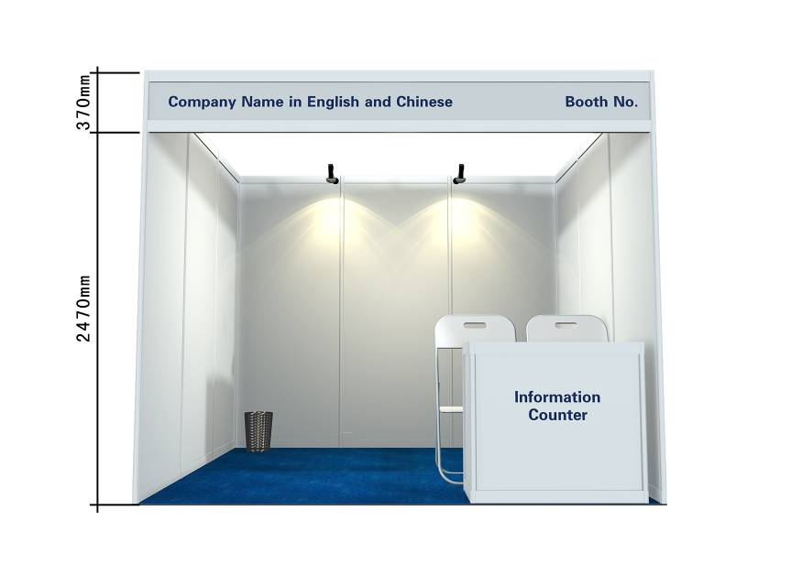
Note ：
1) No free to change content of the fascia board.
2) Without the permission of the official constructor, no dismantling and change to the standard booth.
3) The configuration of 5A/220V single socket, can only be connected to the TV, computers, mobile phones, is strictly prohibited for the machines and lighting.
4) For standard booth enterprises exhibitor, just one day earlier (October 12) report and start to do the installation.

  - During Negotiation between Booth Structures

Deadline date：September.20, 2017
Please E-mail or Fax to：
Weihai International Convention & Exhibition Co., Ltd. （Official Constructor）
Contact Person：Li Yanxu (+86-13963198868)
E-mail：26822966@qq.com
Tel：+86-631-5181809，Fax：+86-631-5325893，
Exhibitor name： |  | Booth No：
Contact person： | Mobile： | Email:
Tel： | Fax：
Negotiations structure design：

- Accurately and clearly with a pen or ball-point pen to draw the negotiations between the design and to ensure that the drawings opening towards accuracy;
- Set up negotiations structures, according to the number of panels to charge the fees by Official Constructor -Weihai International Convention & Exhibition Co., Ltd.
- Ensure timely and effective communication, please complete fill in above, save a copy of the archive retained.

Booth dismantling price：

No | Project | Unit | Price | Quantity | Total price /Yuan
1 | Panel | one | 50
2 | Fascia Board | one | 30

- Raw Space Booth

4.1 Booth Construction Official Service Suppliers
Designated official service suppliers：
Weihai International Convention & Exhibition Co., Ltd.
(Official Exhibition Constructor)
Contact person：Qi Liang (Call Phone: +86-18663153716)
Tel：+86-631-5181801
Fax：+86-631-5182509
E-mail: 1660216354@qq.com
www. Intexwh.com

Weihai International Exhibition Center, (No. 58 Haibin Mid Road, Weihai，Shandong Province 264200, China
Guangfunaji Exhibition & Show Co., Ltd.
Contact Person: Chen Guozheng (Cell phone: +86-13910234923)
Tel: +86-10-57427990
Fax: +86- 10-57571869 ext 8006
E-mail: 361155804@qq.com
www.guangfunaji.com

Rm. 0227, South Building 4, Zhonghong Xiangsu, Wuliqiao,, Chaoyang District, Beijing, 100102, China
Beijing Horizon Exhibition & Show Co., Ltd.
Contact Person: Chen Dongran (Cell phone: +86-13910181313)
Tel: +86-10-67662180/87602180
E-mail: horizon8888@vip.sina.com
www.horizon-s.com.cn

No. 3#-4-404, Zone B, 1st Hongbo Jiayuan, Chaoyang District,
Beijing, 100176, China

4.2 Booth Construction Management Regulations

4.2.1 Procedures of Raw Space Construction

- Designated official service suppliers handle the construction procedures to the official constructor- Weihai International Convention & Exhibition Co., Ltd. before September 20, 2017.

- Construction Fee: Raw space management fee of 15 yuan / sqm (the organizer designated Constructor), 25 yuan / sqm (non-Organizer specified Constructor), construction permit 10 yuan / person, set up deposit of 50 yuan / sqm.

- All drawings shall be marked with the size and specifications of all structural material, prohibited to build two-story booth.

- Fill out and submit “Booth Construction Application Form” and “Water Electrical Application Form” in the field.

- Contractor legal entity or the client sign “The Booth Construction Safety Responsibility”, affix the company seal, and submit the declaration of the scene.

- After constructor paying the construction management fees, construction documents fees, construction vehicle license fees, and connection fees for water, electricity and compressed air booth construction deposit, then constructor receive the construction permits.

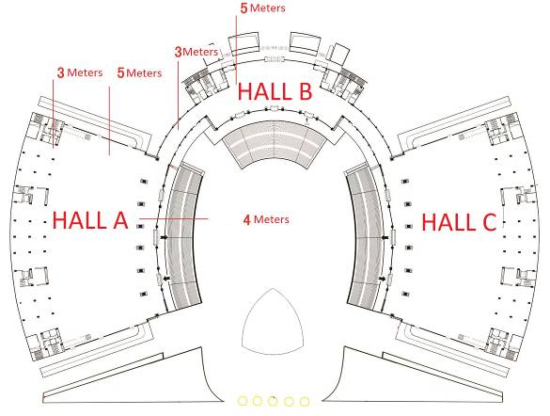
4.2.2 Construction Management Regulations

- Build limit: when the provisions of the exhibition hall and the orhanizer’s is inconsistency, whichever is low (please see right)

- All exhibitors should be dismantling after 16:00 at October.15. 2017; early dismantling will be refused to participate in the next show by organizer. Notify the relevant personnel and verification correct before leaving the exhibition hall, otherwise, all the adverse consequences will be taken by the exhibitor or constructor.

4.2.3 Site Management

Construction unit should be in the prescribed time and area construction, the person in charge on the spot during the whole construction period and the period may not be unauthorized off-the-job.

Construction units in construction should always clean the construction garbage and other types of waste materials, booth material should be in the booth code neatly, no occupation of fire and safety passage for evacuation, maintain the channel. Not in the private setting storage warehouse, or in a public area for booth materials, construction tools, otherwise, the exhibition hall has the right to take the confiscation of treatment, and retention of deduction right construction deposit.

All adjacent booth structure back wall must make appropriate decorative treatment, may not affect adjacent booth display effect.

High-altitude (drop height datum≥ 2m), should use the qualified security lifting tools and operating platform, the construction personnel must wear a safety belt. For personal protection, may fall in range set security zones, and have special care. Safety zone shall be visible warning sign.

Booth structures hidden safety problems of construction unit after receiving the issued “booth structures safety notice ", must be timely rectification, and rectification results reply in a timely manner, under review.

Exhibition hall shall not use the saw, planer and other processing tools.

Exhibition hall prohibited fireworks, the construction unit in the construction period shall not use the electricity, gas welding and other fire operation, fire extinguisher must be at the scene.

Outdoor booth can’t be constructed before 8:00AM and after 21:00 PM, as well as a special period of construction.

After exhibition opening, the construction unit should stay in charge of safety and full-time staff on duty at the scene, found problems in a timely manner.

4.2.4 Safety of Fire, Security, Cleaning and Catering

No smoking in the hall, use of fire is strictly prohibited, a fine of 200 yuan for offenders

Safety of fire: Any temporary structure of matter and leading to the fire hydrants, electrical and mechanical control room door and the alarm contact points to maintain at least 1.2 m channel. All aisles at least 3 meters wide, fire exits prohibit placing objects, once found that it will be cleared, and build contractors and exhibitors take all responsibility.

Cleaning: keep cleaning during the installation, the show time and the Dismantling time.

Security: exhibitors shall comply with all safety requirements with the hall security department.

Lost and Found: check with the security office, should be signed with your ID card to receive, all the lost and found will be classified for 30 days, more than 30 days, the exhibition hall will handle the items.

Catering services: exhibition specified dining area in the second floor of Hall C; do not eat the lunch provided by other unofficial organizers.

4.2.5 Special Decoration Water and Electricity Management

1) To ensure the safe use of the exhibition water, electricity and compressed air, the unified management of the exhibition hall on water, electricity and compressed air.

2) Electrical construction personnel must hold a professional operation certificate issued by the state labor department, should strictly abide by the rules and regulations during the construction period, no illegal operations with the exhibition hall check.

3) To install a variety of lighting and various electrical facilities and materials in exhibition hall should have a national professional safety certification.

4) All power lines should be sheathed copper wire, double insulation and dielectric strength required to meet the standard, to connect the lamps insulated conductor’s minimum cross- sectional area of 1mm2.

5) Different voltage lines to be routed separately. Power electricity and electricity for lighting must be used separately, for the construction unit to tap the power of electricity lighting; the exhibition hall will give the punishment. Each power should be the installation of protective devices, shall not be overloaded electricity. The lighting circuit comes with the distribution panels and control switches.

6) Stand electrical connection terminals must be closed completely, shall not be exposed

7) Using temporary power needs to bring your own wires during the construction, the center line can not have a connector, and it should have the protection switch.

8) Electric sand, table model, light box should be made by flame retardant or flame-retardant materials.

9) The installation of high-temperature lamps should have the effective protection measures in exhibition area. High temperature, light fixtures, should be installed more than 2.5 meters. Prohibit using neon as booth stand decorative lighting.

10) Construction units, exhibitors are not allowed to connect to the electrical equipment in the hall-powered equipment and lighting or power lines without authorization; otherwise all the consequences will be taken.

11) The laying line of the exhibition hall should be fixed; You should use the cover to be protected.

12) Combustible materials and other debris should no place around the Water, electricity, gas facilities of inside exhibition hall. Around the booth construction can not affect the operation of the water, electric equipment.

13) Strictly prohibited straight drainage, if the machine with water, exhibitors must bring their own water cycle device, or the exhibition hall has the right to refuse water applications.

14) The exhibition hall is not allowed by storing and using the pressurized pressure vessel.

15) Exhibition hall provides the general compressed air with outlet pressure 0.6-0.8Mpa; exhibitors should be based on their own situation to install ate the dryer and filter.

16) Special gas required exhibitors to bring their own air compressor and storage tank, and should be placed in the specified location outside the hall, and to make sure the safe operation of equipment.

17) If found in violation of these provisions and insecurity, the exhibition hall has the right to stop the power supply, water supply, gas supply at any time without notice.

18) The exhibition hall reserve special restrictions on the rights of the special circumstances, and the hall have the right to enter and check the exhibitor’s booth

19) According to the facilities of the exhibition hall, the exhibition hall reserves the right to accept and reject the application proposed by the water, electricity, gas requirements.

4.2.6 Notes

1) Construction Personnel shall wear uniforms, and wear safety hat and the effective construction certificate issued by the hall to enter the show, Construction worker enter the exhibition hall must wear the construction certificate, the construction certificate shall not be altered, copied and lent.

2) Construction Personnel to comply with the construction regulation of exhibition hall, they should work within the region and not unauthorized to work in non-work areas and non-work time.

3) Construction Personnel should pay attention to security and civilized construction, wear the safe protection equipment to ensure a safe work environment

4) Construction Personnel should take good care of exhibition public facilities; debris shall not be piled up on the green grass.

5) No smoking in the exhibition hall.

4.3 Raw Space Booth Construction Process

1） Fill in the application materials
The construction procedures of raw space and approach related accessories, please call the official constructor to obtain (Weihai International Convention&Exhibition Co., Ltd)

2） Application materials audit flowchart
Weihai International Convention & Exhibition Co., Ltd. (Official Constructor)
Contact person：Li Yanxu (Call Phone: 13963198868)
Tel：+86-631-5181801
Fax：+86-631-5182509
E-mail: 26822966@qq.com
www. Intexwh.com

3）Apply for venue services
a) According to the venues, service orders to fill in the necessary services and the number (Appendix 4)
b) Send orders and the number within 10 working days.
c) Venues confirm the order and reply
d) Prior to the order funds to the designated account within seven working days of approaching exhibits.
4） The approach procedures
a) The exhibition hall Services Department for processing approach procedures
b) Receive construction permits.
c) Structures requests for services from Integrated Service according to the needs

5) Carry out services during the show
a) If the service needs to apply to venues Service for show time period.
b) Pay the service fee to apply for services.
c) Field service personnel to provide appropriate services

6) Procedures of exit
a) Booth exhibition facilities and the waste are shipped out of the hall
b) Venues Service staff to check the move-out and sign to confirm.
c) Venues Office process deposit refund procedures

  - Booth Construction Over-time Work

Price:
Area | Time | Price(Yuan/hour) | Remark
Under 50 sqm | 17: 00--21: 00 | 150 | After 24:00 each day, every 50 sqm charge 200 yuan/hour.
Under 50 sqm | 21: 00--24: 00 | 200 | After 24:00 each day, every 50 sqm charge 200 yuan/hour.
50-100 sqm | 17: 00--21: 00 | 250 | After 24:00 each day, every 50 sqm charge 200 yuan/hour.
50-100 sqm | 21: 00--24: 00 | 400 | After 24:00 each day, every 50 sqm charge 200 yuan/hour.

《Overtime Application Form》

Deadline Date：For overtime, during the construction day at least four hours in advance to make an application.
Please E-mail or fax to：
Weihai International Convention & Exhibition Co., Ltd. （official constructor）
Contact person：Li Yanxu (+86-13963198868)
E-mail：26822966@qq.com
Tel：+86-631-5181809，Fax：+86-631-5182509
Exhibitor name： |  | Booth No：
Contact person： |  | Mobile：
Email:
Date

Time

4.5 Water/Electricity/Compressed air Supply

《Water/Electricity/Compressed Air Application Form 》

Deadline Date：September.20, 2017.
Please E-mail or Fax to：
Weihai International Convention & Exhibition Co., Ltd. （Official constructor）
Contact Person：Li Yanxu (+86-13963198868)
E-mail：26822966@qq.com
Tel：+86-631-5181809，Fax：+86-631-5182509
Exhibitor name： |  |  | Booth No：
Contact person： |  |  | Mobile：
Email: |  |  | Tel：
Project | Specification | Unit Price(Yuan) |  | Quantity | Amount（Yuan）
Water |  | 5yuan/ton
Electricity |  | 1. 5yuan/KMh
Temporary power | 5A/220V | 100
24 hour electricity for lighting | 5A/220V | 200
Power electricity | 15A/380V | 450 |  |  | Include: construction costs, management fees, electricity, 24 hour for electricity(200Yuan)
Power electricity | 30A/380V | 850
Power electricity | 60A/380V | 1450
Power electricity | 100A/380V | 2250
24 hour Power electricity | 15A-100A | Electricity consumption*1. 4
Water for booth(L10M) | Water with booth (Diameter:10mm) | 200
Water for booth(L10M) | Water with machine (Diameter:10mm) | 500
Remark | Water, power and apply one week before the exhibition, the additional 30% rush fee for temporary application during the exhibition installation time

5. Service Order

5.1 《Exhibition Furniture, Lighting, Office, Network Application From》

Deadline date：September.20, 2017
Please E-mail or Fax to：
Weihai International Convention & Exhibition Co., Ltd. （Official constructor）
Contact Person：Li Yanxu (+86-13963198868)
E-mail：26822966@qq.com
Tel：+86-631-5181809，Fax：+86-631-5182509

Exhibitor name： |  | Booth No：
Contact person： |  | Mobile phone
Email: |  | Fax：

Project | Specification | Unit Price(Yuan) | Quantity | Amount（Yuan）
Square table | 650mm×650mm×700mm | 100
Low glass case with lockable | L(1m-1.4m)*W(0.3m-0. 4m) *H1m | 200
Flat Shelf | 1000mm*300mm | 30
Wallboard | 950mm*2500mm | 60
Carpet | SQM | 20
Plastic chair | ONE | 30
Floodlight | 40W | 30
Longarm spotlight | 60W | 30
Power supply | 5A/220V | 100
Network | With wiring costs, information costs, materials costs, commissioning fees. | 200
Cleaning | 8 hours | 120Yuan/person/day
Type | A4/page | 3
Print | Comes with removable storage/page | 1
Email | 10 minutes/time | 3
Fax |  | 3、5
A3 coping | A3/page | 3
A4coping | A4/page | 1
Receive Fax | Page | 3

Below are the pictures of exhibition furniture for your reference. Please in kind prevail.

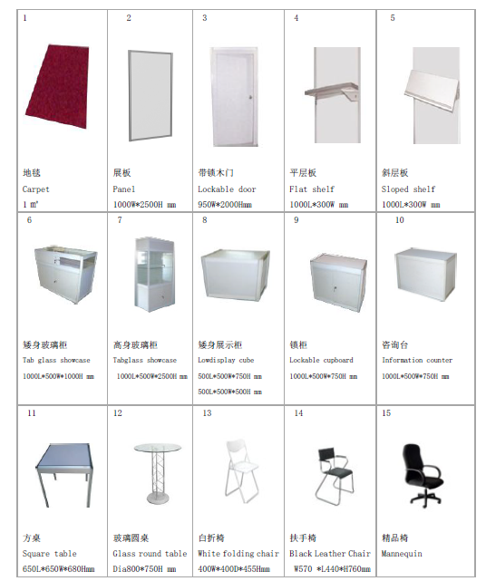

5.2 Hotel Reservation

Deadline date：September.20, 2017
Please submit the reservation form to：
Ms. Emily Zhang E-mail：service_d@chinafish.cn
Tel：+86-10-58203101/02/03，Fax：+86-10-58203100

《Hotel Reservation From》
Name: (Mr. /Mrs. /Ms.) Badge No: __________________________
Company: Country: ___________________________
HOTEL RESERVATION:
Item | Hotel | Star | Type Room | Price(RMB)
01 | Haiyue Jianguo Hotel  (12km to the venue/ free shuttle bus) | ★★★★★ | Single/ Double | RMB 490 NET (street-view)  RMB 570 NET (sea-view)  (Breakfast & Service charge included)
02 | Golden Bay Hotel  (15km to the venue/ free shuttle bus) | ★★★★ | Single/ Double | RMB 440 NET (street-view)  RMB 550 NET (sea-view)  (Breakfast & Service charge included)
03 | Baohai Hotel  (1km to the venue/ free shuttle bus) | ★★★★ | One Bed | RMB 378 NET(street-view)  RMB 418 NET (sea-view)  (Breakfast & Service charge included)
03 | Baohai Hotel  (1km to the venue/ free shuttle bus) | ★★★★ | Two Beds | RMB 338 NET (street-view)  RMB 378 NET (sea-view)  (Breakfast & Service charge included)
04 | Guishe-Four Seasons Hotel  (2km to the venue/ free shuttle bus) | ★★★★ | One Bed | RMB 350 NET(street-view)  RMB 400 NET (sea-view)  (Breakfast & Service charge included)
04 |  | ★★★★ | Two Beds | RMB 320 NET (street-view)  RMB 350 NET (sea-view)  (Breakfast & Service charge included)
(Reference: Exchange rate USD1.00 ≈ RMB 6.60)
Note:
- Reference Exchange Rate: the fee is to be paid according to the exchange rate released by Bank of China on the payment day.
- Special room rate has arranged for guests before 20 September, 2017. The room rates will be higher after this date. Booking is on the first-come-first-served basis.
- More hotels and more information to visit website: www.cgcexpo.com

1st Choice Hotel: Number of Rooms:
2nd Choice Hotel: Number of Rooms: _________
Check-in Date: / / (dd/mm/yy);
Check-out Date: / / (dd/mm/yy)

Bed Preference:
□ Single (1 person/ 1bed) □ Double / Double ( 2 persons / 2 beds) □ Double ( 2 persons / 1 bed) □Street-view □Sea-view □ Non-Smoking □ Smoking Others ______

Signature: Date:

5.3 Translation service
Deadline date：September.20, 2017
Please submit the reservation form to：
Ms. Emily Zhang E-mail：service_d@chinafish.cn
Tel：+86-10-58203101/02/03，Fax：+86-10-58203100

《Translation Service Order Form》

Deadline date：September.20, 2017
Please submit the reservation form to：
Ms. Emily Zhang E-mail：service_d@chinafish.cn
Tel：+86-10-58203101/02/03，Fax：+86-10-58203100

Language | Price(RMB) | Remark
English | Free | - Is scheduled at least one day, not enough one day by a day calculation.  - Need to book in advance and pay
Korean, Japanese: | USD120/person/day(8 Hours)
Booking information：
Language: □ English □ Korean □ Japanese
Service day: from October 2017 to October 2017, Total days

5.4 Visa invitation

《Visa Invitation Form》

Deadline date：September.20, 2017
Please submit the reservation form to：
Ms. Emily Zhang E-mail：service_d@chinafish.cn
Tel：+86-10-58203101/02/03，Fax：+86-10-58203100

Note:
Please send the form to us with a copy of personal information page of your passport, and previous visas issued by Chinese Embassy if any. Thank you!

Booth No.:
Name: (must be the same as your passport)
□ Male □ Female Position:
Company Name:
Date of Birth: (dd/mm/yy) Place of Birth: (Country)
Nationality: Passport No.:
Issued by: Date of Expiration:
Date of entry into China: (dd/mm/yy) Duration of stay: day(s)
To which Chinese Embassy or Consulate in your country you wish to apply for your visa:

Note:
- You shall apply for your visa at Chinese Embassy or Consulate in your country by the invitation letter before you travel to China.
- The Invitation letter will be issued by Weihai Municipal government at free of charge.

5.5 Exhibits Transport

5.5.1 Exhibitor own commissioned transport

Contact ： State the exhibitor name on the waybill, address zip code, contact information, booth number mark, a valid certificate for delivery.

Consignee: Hou Xiaoyan, Tel:+86-631-5181809, Fax: +86-631-5181806, Mobile:+86-18389168496

Price list：
Project |  | Price | Remark
Van rental | Hand hydraulic car | 40yuan/each/hour | Deposit 1000yuan
Van rental | Flatbed truck | 30yuan/each/hour | Deposit 300yuan
Van rental | Hand push trolley | 30yuan/each/hour | Deposit 300yuan
Folklift truck | 3 ton | 1400yuan/day | 6 hours/day  (under 2 ton )
Folklift truck | 3 ton | 300yuan/hour | 6 hours/day  (under 2 ton )
Small truck |  | 100yuan/hour | Not enough one hour by a hour calculation.  6 hour/day
Small truck |  | 500yuan/day | Not enough one hour by a hour calculation.  6 hour/day
Porter |  | 40yuan/hour | Not enough one hour by a hour calculation.  6 hour/day
Porter |  | 150yuan/day | Not enough one hour by a hour calculation.  6 hour/day
Crane |  | 600yuan/hour | Not enough one hour by a hour calculation.  6 hour/day
Crane |  | 2000yuan/day | Not enough one hour by a hour calculation.  6 hour/day
City freight | Small truck | 150yuan | Agent delivery exclude the storage charges.
Warehousing |  | 5yuan/day/㎡

5.5.2 Exhibition Designated Transport Company
1. Exhibition designated transport company:

Freight Forwarder Kerry EAS International Logistic Co., Ltd, WeiHai branch.

Add: Room 101.103. First floor No 30 HaiBin South Rd., WeiHai. 264200, Shandong Province
Contact person：Wang Zhaolin（+86-13863138933），Email： Zhaolinwang@kerryeas.com
Sun Donghua（+86-13706318650）
Tel：+86-631-3668023 / 3668025，Fax：+86-631-3668026

2. Exhibition designated transport company:
DEPPON LOGISTICS CO., LTD. (Weihai Branch)
Contact Person: Wu Zhibin, Phone: +86-13863138933
Tel: +86-631-3668023/3668025
Fax: +86-631-3668026
Email: 535607303@qq.com
Website: www.deppon.com
Address: No. 198-6, Huoju Rd., Hi-tec District, Weihai, Shandong, 264209 China
(Please visit the website to know more transport fee and make sure to contact transport company before sending out your exhibits.)

6. Exhibition promotion

6.1 Exhibitor Information (For Buyer’s Guide of CGC (Weihai) EXPO 2017)

《Exhibitors Registration Form》

Deadline date：Aug. 20, 2017.
Please submit the reservation form to：
Ms. Emily Zhang E-mail：service_d@chinafish.cn
Tel：+86-10-58203101/02/03，Fax：+86-10-58203100

Note: ensure the accuracy of the information, orgabizer only accept the electronic version.

* Booth No |  |  |  | Company LOGO(Resolution 300dpi, Size 200k，Email Submission to: service_d@chinafish.cn)
*Company Name(English)
*Company Name(Chinese)
Special Note: if it is standard booth, the English and Chinese names of above will be used as the English and chinese fascia word of the booth.
* Address(chinese) |  |  |  |  |  |  | * Postcode:
* Address(English)
* Tel |  |  |  |  | * Fax
Email
Website
* Contact |  | Name |  |  | Post | Contact(Mobile or Email)
Company Registered Trademark |  | Chinese:  English:
* Company Business Classifications: (In a suitable program“√”, can choose the multiple projects acoording to the actual Situation)
□ Manufacturer □ Wholesaler □ Retailer □ Sales company
□ Agent □ Media □ Organization □ Other:
* Company Product: (According to the primary and secondary sequence), and please detailed product classification spaces zoned "√". Please fill sequentially product number: 、 、 、 、 、 、 、 .
Product Number:
- Rods
- Reels
- Lines
- Hooks
- Lures
- Baits
- Floats
- Nets
- Fishing Accessories
- Clothing
- Bags
- Tackle Box
- Kits’ Tackle
- Electronics
- Giftware
- Tackle Accessories
- Fly Fishing Products
- Ice Fishing Products
- Out Leisure Products
- Outdoor Sports Products
- Fishing Boats/Yachts/Fishing Boats Accessories
- Tackle-making Equipment
- Tackle-making Materials
- Packing Materials/Printing/Patching
- Books/Audio-visual Products/Fishing Rubbing
- Fishing Tackle Trade & Consulting
- Non-Fishing Tackle

  - Exhibition Advertising

Catalogue Advertisement Booking Form

Deadline date：September 6, 2017.
Please submit the reservation form to：
Ms. Emily Zhang E-mail：service_d@chinafish.cn
Tel：+86-10-58203101/02/03，Fax：+86-10-58203100

Advertisement |  | Price (RMB) | Size Requirements | Booking Quantity
Internal Full page color advertisement |  | 1,500 | 175mm*250mm
Remark | 1) Exhibitor are required to provide the advertising manuscript, the organizing committee is not responsible for the advertising production.  2) Bleeding size requirements: 178mm*253mm.  3) Format AI or JPG, Resolution not less than 300dpi.  4) Exhibitors design own journal advertising, the organizer only assist free modify one or two times.  5) Exhibitors are required to ensure the advertisement manuscript is not in violation of the ad vertisement Law of PRC etc.

6.3 Exhibition Hall Advertising

<< Exhibition Hall Advertisement booking Form>>
Deadline date：September. 20, 2017
Please Email to：Weihai International Convention & Exhibition Co., Ltd.
Contact Person：Jiao Jinghua (+86-15263148968)
Tel：+86-631-5181801 Fax: +86-631-5182509，E-mail：359264656@qq.com
Exhibitor Name： |  | Booth No：
Contact person： |  | Mobile phone：
Email: |  | Tel：

Advertising Schematic diagram | Size | Quantity  (available) | Price (Yuan) | Order
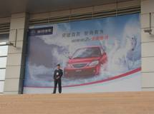 | 9.8M×5.2M | 2 for A or C Hall | 4000
 | 8.8M×5.2M | 4 for(Hall B) | 4000
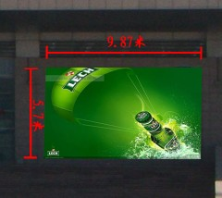 | 9.8M×5.6M | 2 for A or C Hall | 4000
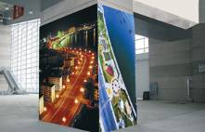 | W375CM  H310CM | 6 for A/C Hall | 2500
 | W200CM  H310CM | 6 for A/C Hall | 2500
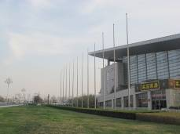 |  | 12 for each roadside of A/C Hall | 100

6.4 SPONSORSHIP

6.4.1 Qualification of Sponsor
a）CGC 2017 exhibitors only;
b）Those enterprises having great influence on the world tackle industry;
c）Having good profitability and fine reputation;
d）Void of any business dispute (about intelligence property rights or business trade) in recent three years;
e）those enterprises having proprietary intellectual property rights and private brand are welcomed.

6.4.2 Sponsorship Opportunities
*Hand Bag *Staff Clothing
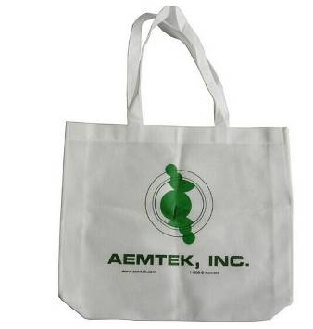


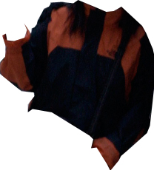

*Badge Holders *Bags for Buyers/Exhibitors as gifts
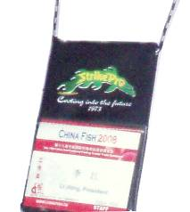

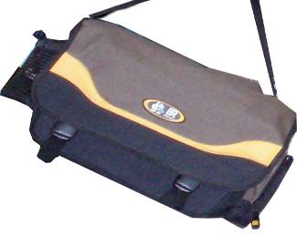

6.4.3 Sponsorship Application Form

Deadline date：September. 20, 2017
Please submit the reservation form to：
Ms. Emily Zhang E-mail：service_d@chinafish.cn
Tel：+86-10-58203101/02/03，Fax：+86-10-58203100

Exhibitor Name： |  | Booth No：
Contact person： |  | Mobile phone：
Email: |  | Tel：

Sponsor Item:

6.4.4 Sponsoring Instruction
a) Alteration of sponsor project information and price are reserved by the organizer;
b) Before carried out, the design program of the sponsored goods must reach the agreement between the exhibition Organizer and the Sponsor;
c) The sponsored goods shall be sent to the Organizer appointed place before September. 20, 2017.

If any questions, please contact us.

Tel: +86-10-58203101/2/3
Fax: +86-10-58203100
E-mail: Lijiang@chinafish.cn
Website: www.cgcexpo.com

